I chose to do this lab in Python over MATLAB as I am more comfortable with it. I will write all the code in a Jupyter notebook, to make it more readable. I will use Microsoft Visual Studio Code as my IDE, with the Python and Jupyter extensions installed. Code is formatted to the Black code style.
I start by importing NumPy, mainly for its support for n-dimensional arrays, which will be helpful when defining and working with the simulation grid. I also import matplotlib for graph plotting later.
I defined the simulation parameters, such as grid_pts, as global variables so that they don’t have to be passed around as arguments to every function.
I began writing the solve_laplace function. While writing this, I needed to implement the residuals function. One thing I noticed while writing this is that at the edges of the grid, certain values in the residuals function are undefined (for example, when , there is no ). So, we check if we are on an edge, and adjust accordingly. I also accordingly change the 4 to a 3 or a 2 if this is done. For example, if we are at the upper left corner ((0,0) in the matrix, equivalent to the x-y position (0,1)) the formula becomes

Having written the code for this, I calculated the analytic solution:
INSERT CALCULATIUON HERE
I then compared this to the numerical solution. To get a visual representation of at every point for debugging purposes, I plotted a heatmap using the imshow() function from matplotlib.pyplot. The colourmap used is “rainbow”.
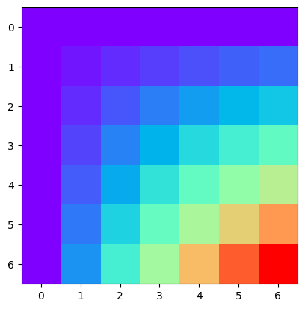
To get 2d arrays of x and y values at every point, I used the linspace function from numpy to get 7 evenly distributed values in the interval [0,1], and then used the meshgrid function to get two 2D arrays, with x and y values at every point. The first time I did this, I got the following result:
Which is close, but we want y=0 at the bottom, and the axes are mislabeled. Using np.flip() on the Y array fixes this. Changing the axis tickmarks and adding some labels gives:
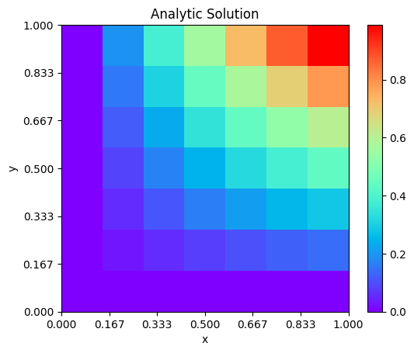
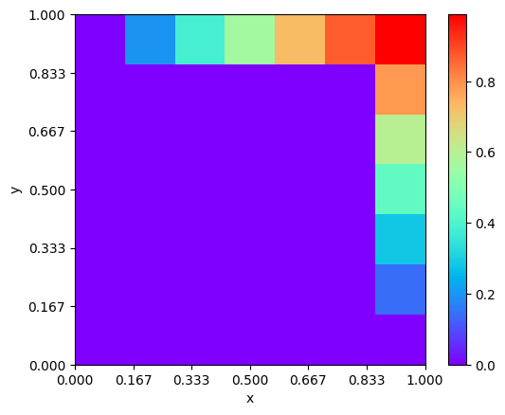
I then move on to getting a numeric solution. I plotted the initial conditions to check that they were correct, and after a little bug fixing, I got the expected grid:

I then ran the code. My first result clearly showed some errors:

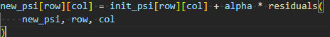
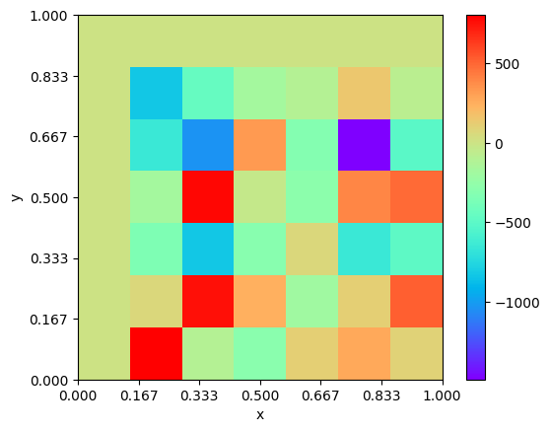
I traced the problem down to the line
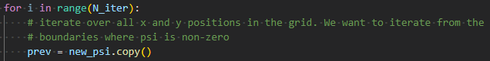
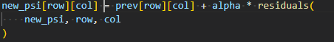
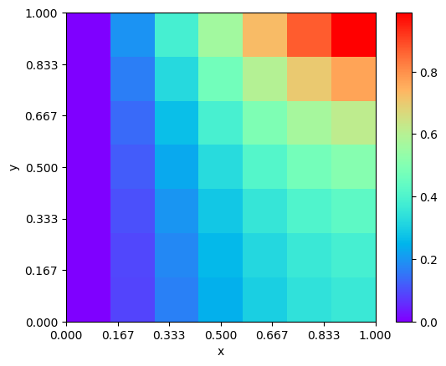
As can be seen, the code updates using the initial state each time, rather than the previous one in the increment. To fix this, at the start of each iteration, we save the state from the previous iteration, and use this. The new code is:
This improves the situation, but for some reason, the boundary condition is not met:
I realised that the range(start, stop, step) function in Python does not include the step term, so I accordingly adjusted the bounds of the ranges. I also made sure to iterate along the non-zero boundaries first:
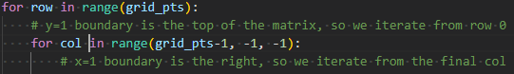
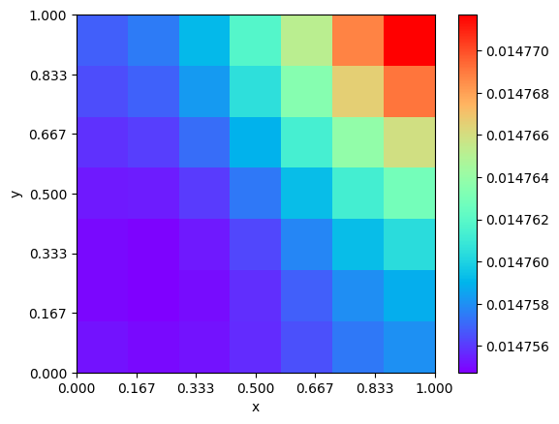
This is getting closer, but the scale is messed up, not going between 0 and 1 as expected. Also, the boundary conditions are not met along the edges:
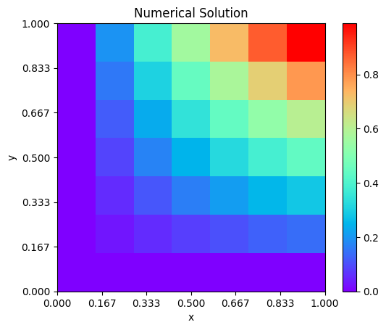
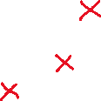
I then realised that at each step, I should re-impose the boundary conditions. Doing this finally yields the correct result.
I now implement some other requirements of laplace_solver(). The first is convergence testing. This is done by comparing the previous iteration to the current one at the end of each iteration. I use np.allclose() to check if all elements of both arrays are equal to within some relative and absolute tolerance. Here, I choose a relative tolerance of and an absolute tolerance of , as at this point the grids will be pretty much indistinguishable. If we reach convergence, the iteration is ended, and a message is printed out detailing how many iterations convergence took to achieve. If convergence is not achieved, a message is printed indicating this.
I now need to implement the historical values capability of laplace_solver(). To do this, I chose the x-y coordinates of (1,2), (3,3) and (4,5) (marked above as red crosses). These correspond to matrix indices of (4,1), (3,3) and (1,4) respectively.
This thankfully worked first time. To compare rates of convergence, I plotted the historical values over iterations for each specified point, for different alpha values. During this, process, I had to overcome a number of problems:
- In order to work out how to produce multiple plots in the same figure, I had to consult the matplotlib documentation.
- Each alpha value has 3 lines plotted for it (since there are 3 points that we are testing at), so when I initially generated a legend, there were repeat entries. To fix this, I again consulted the matplotlib documentation to generate a custom legend.
- Since convergence ends the process early for some of the alpha values, the values in the graph would suddenly jump to zero after this point. To fix this, I added the following code to the end of laplace_solver, which truncates the array of historical values if iteration is ended early:

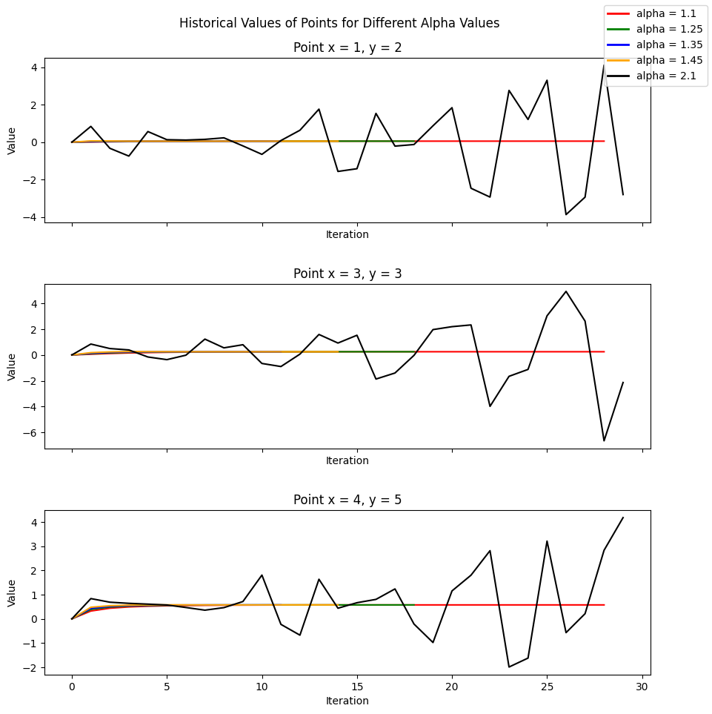
After fixing these and styling the figure, we get the following:
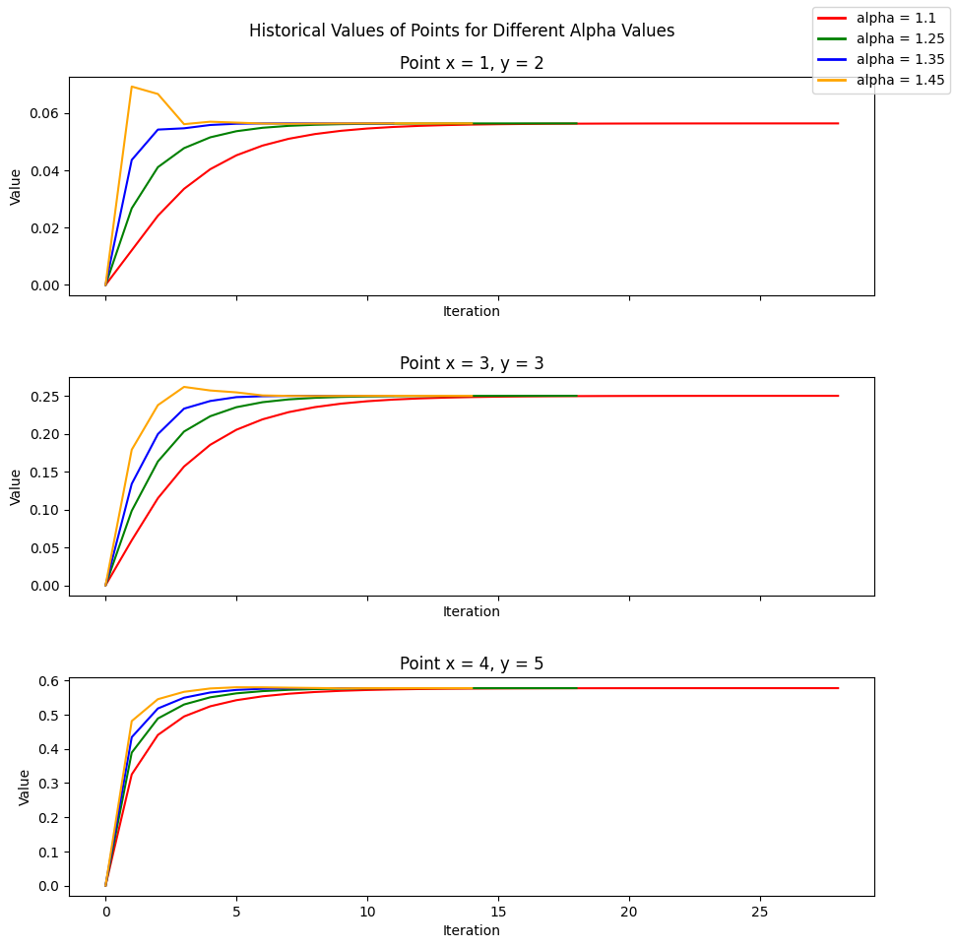
As can be seen, all alpha values lead to relatively quick convergence, except for , which leads to divergence. This is expected, since for convergence, we require . The large fluctuations in the case distort the graph scale, so in order to distinguish between the other cases, we can choose not to plot this, giving the result:

As can be seen, the fastest convergence occurs when the over-relaxation parameter is somewhere between 0.35 and 0.45. The optimum value for 7 grid spacings in x and y directions is

Which makes sense given our graphs.

Finally, I will produce contour plots, as requested by the script. To do this, I again consulted the matplotlib documentation to learn how to use the necessary function, in this case matplotlib.pyplot.contour(). I again used the rainbow colormap. Doing this with 10 contour lines gives:

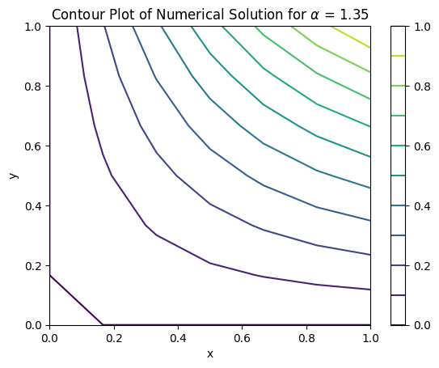
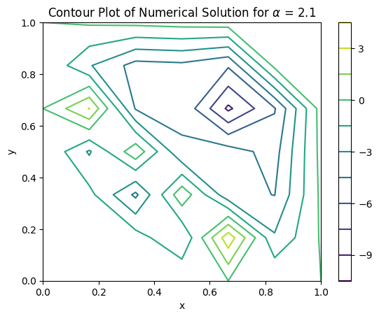
Which looks as expected. Other values of between 1 and 2 look identical, since they all converge. However, the divergence caused by setting leads to some interesting results:
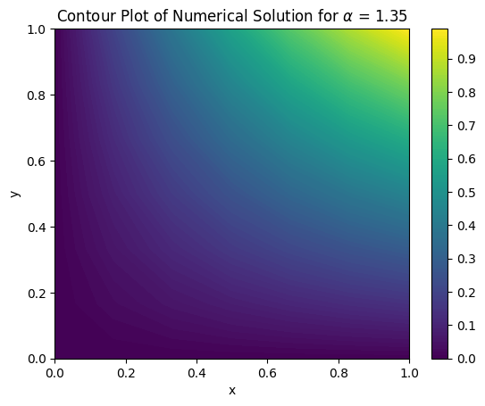
Interewstingly, matplotlib also has a contourf() function which fills in the gaps between contour lines. By using this, with a large number of contour lines (eg. 100), we can get a more smoothly interpolated version of the earlier heatmaps:

https://github.com/psf/black
https://numpy.org/
https://matplotlib.org/stable/gallery/subplots_axes_and_figures/subplots_demo.html
https://matplotlib.org/stable/gallery/text_labels_and_annotations/custom_legends.html
https://matplotlib.org/stable/api/_as_gen/matplotlib.pyplot.contour.html

